**MEDIA DISTRIBUTION USING AWS SERVICES.**

**TASK:**

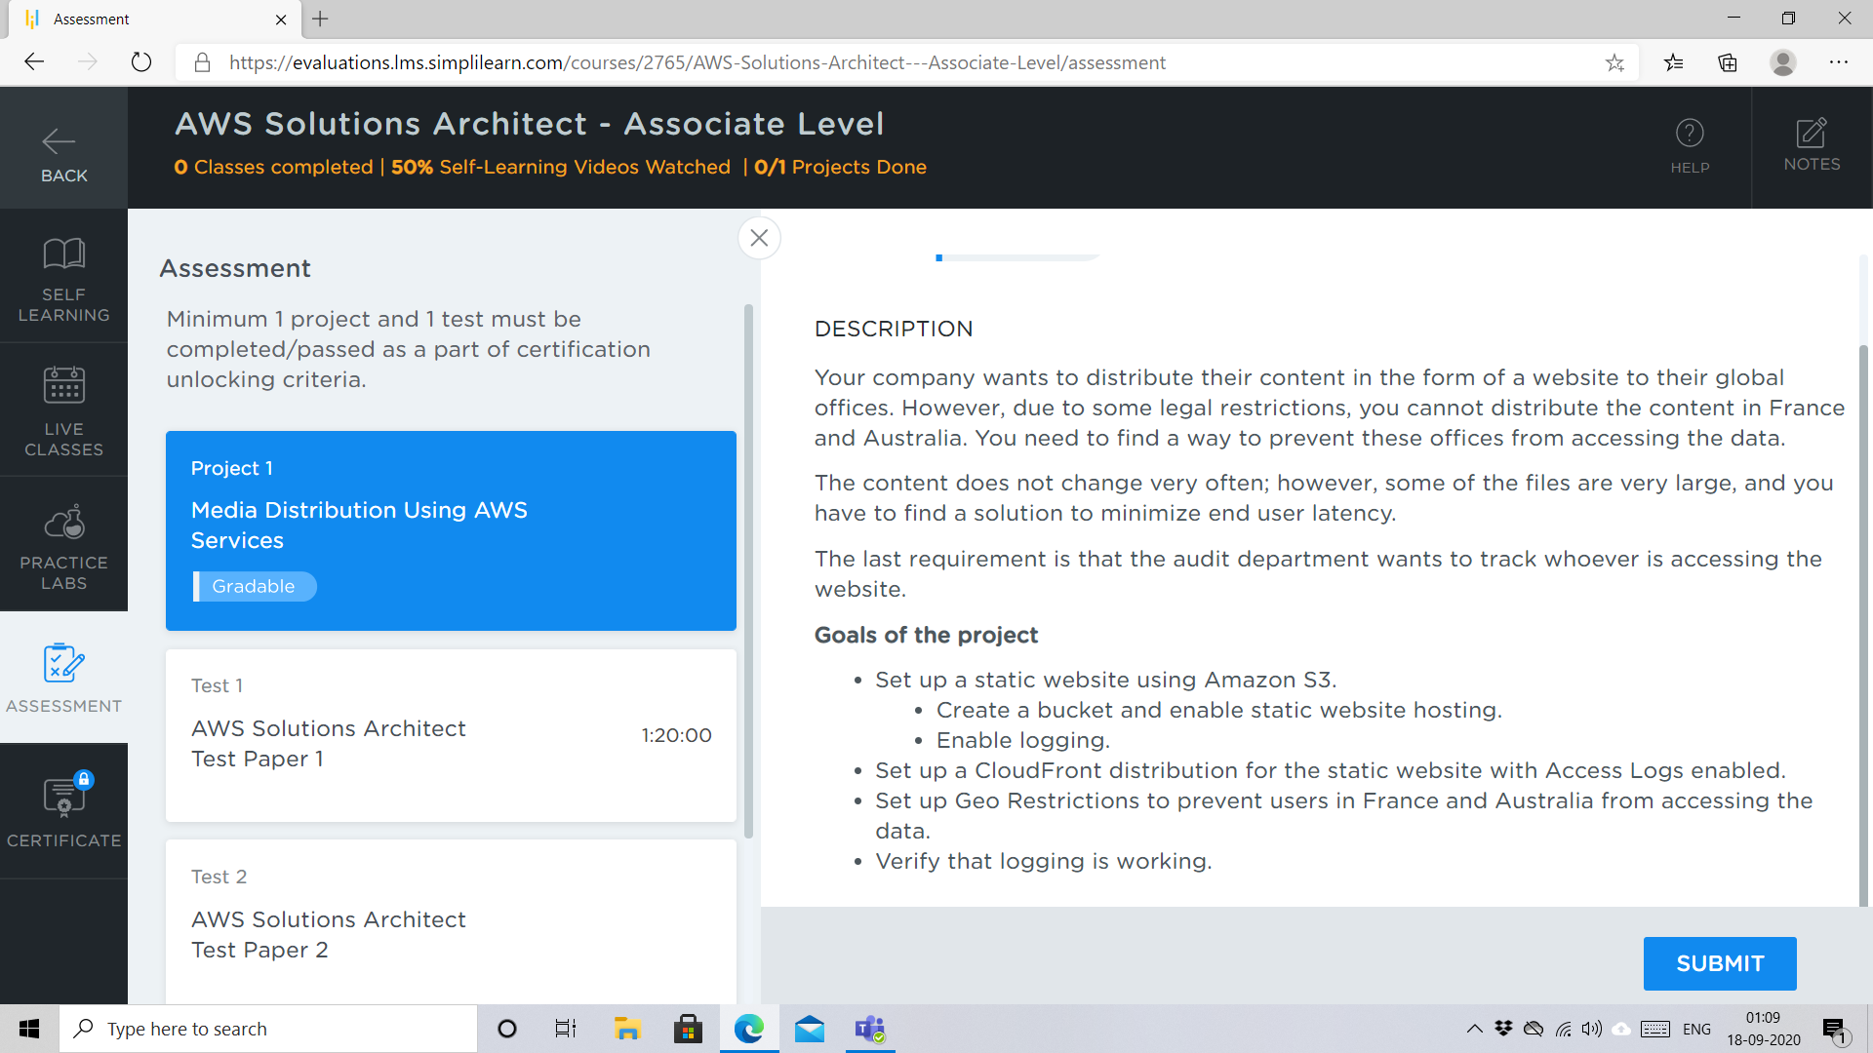

**IMPLEMENTATION:**

STEP1:

Created a simple html page deebi.html to host.

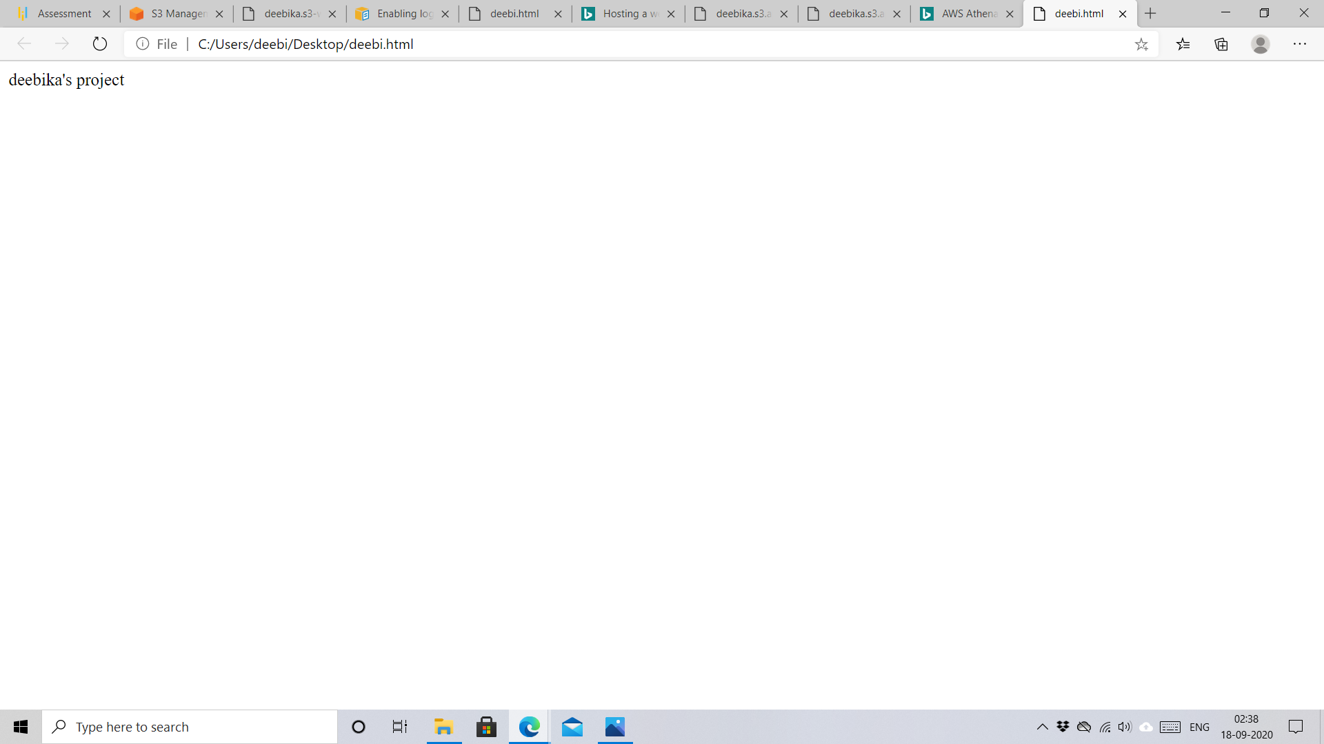

STEP2:

Setting up a static website using Amazon S3.

Created a bucket and uploaded deebi.html

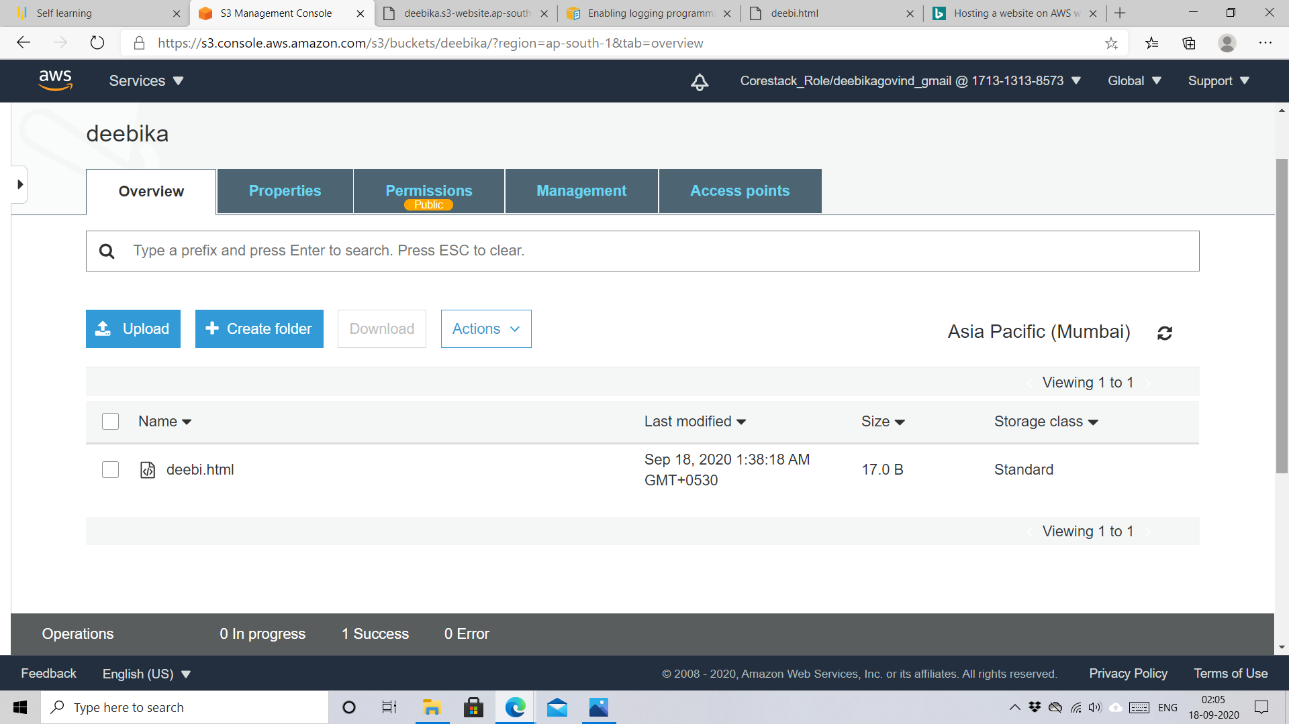

deebi.html is hosted as a static website with enabled logging.

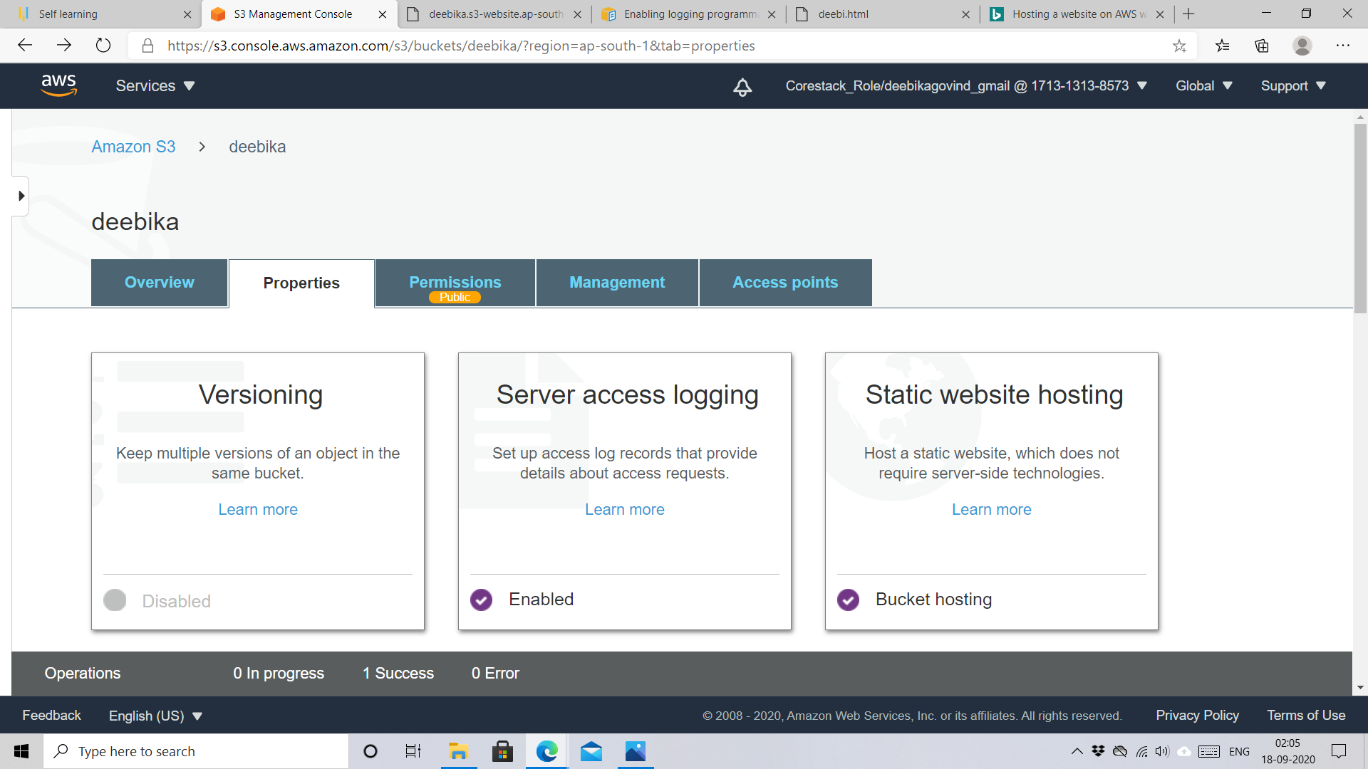

Now, deebi.html can be accessed anywhere in the world using URL:

Deebikas3-website.ap-south-1.amazonaws.com

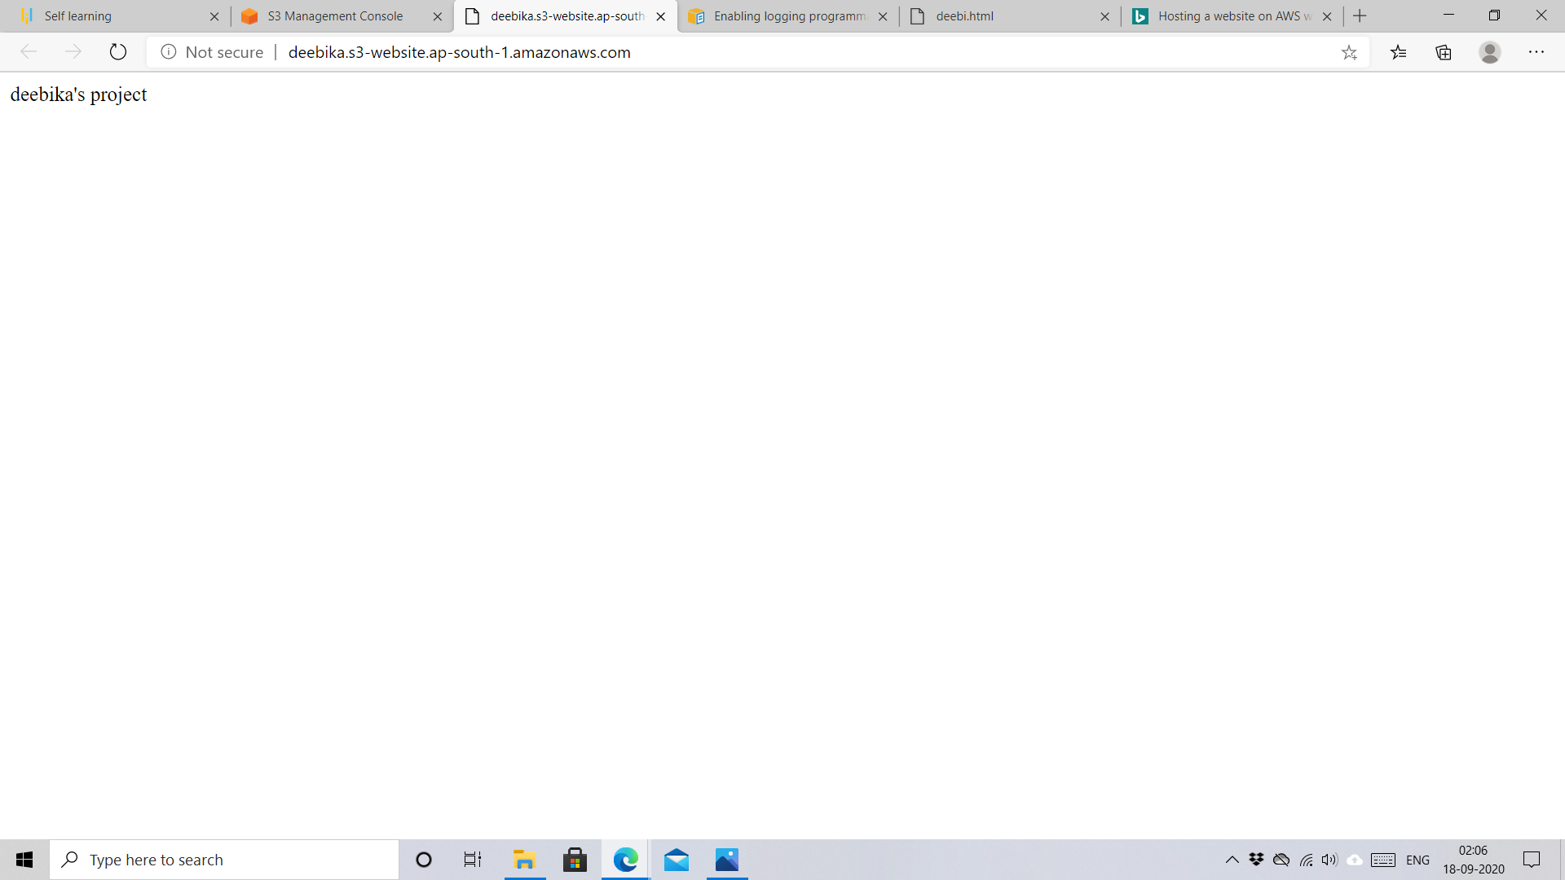

STEP3:

Setting up CloudFront Distribution for the static website with Access Logs Enabled.

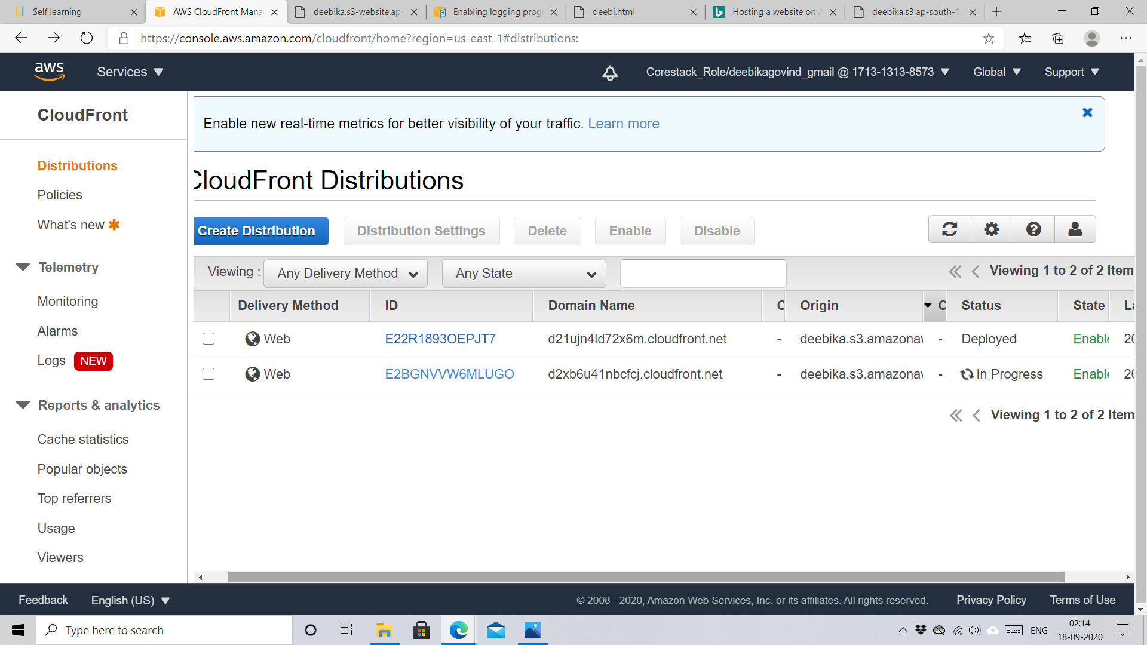

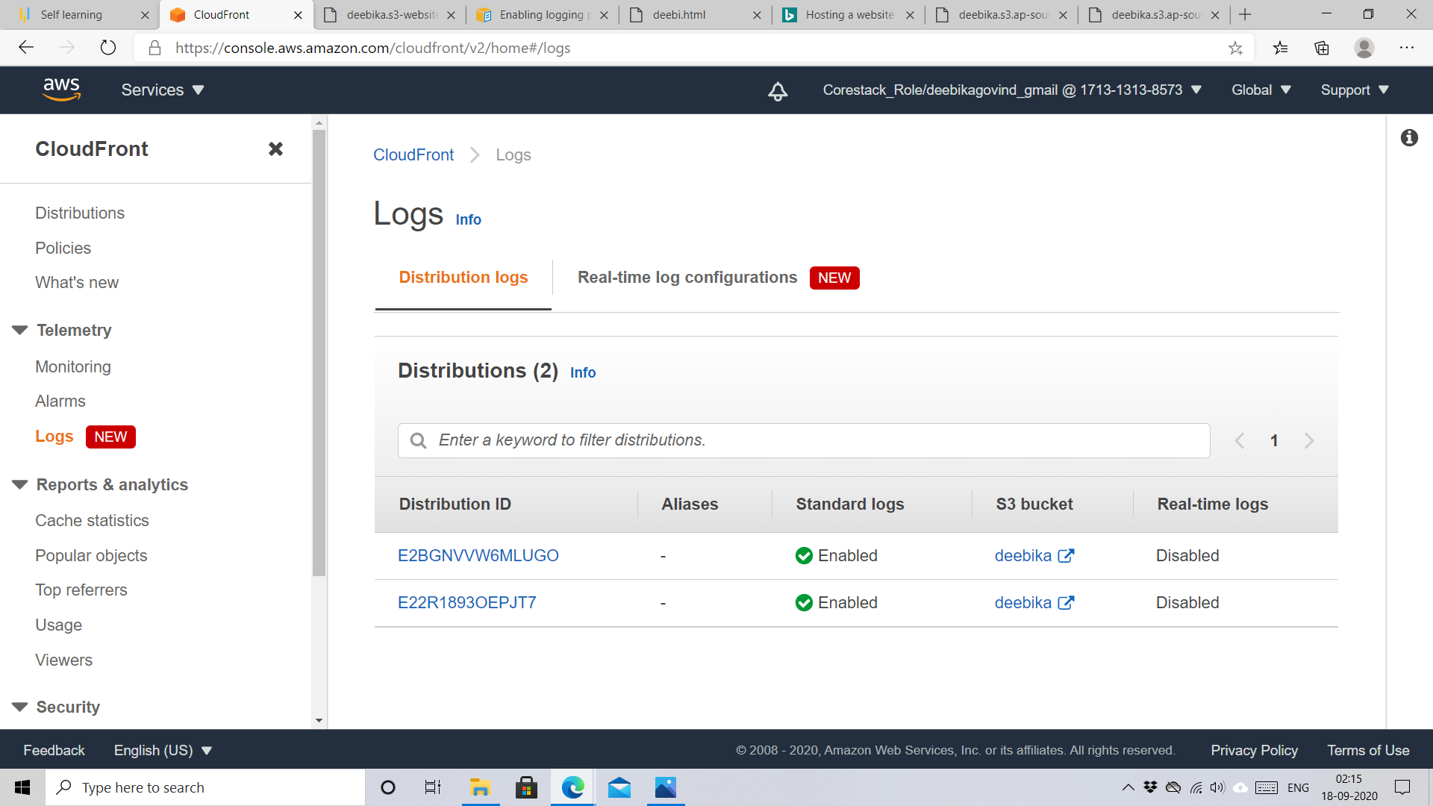

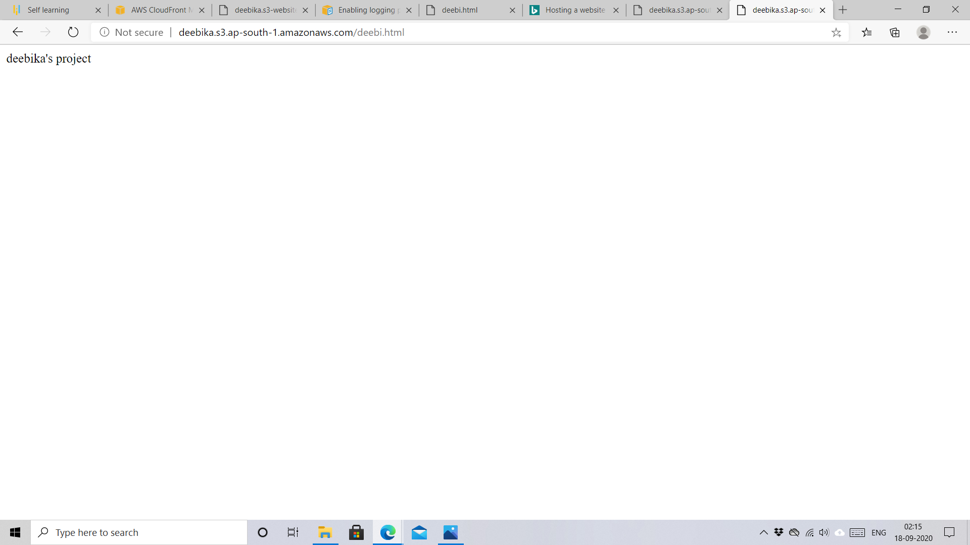

STEP 4:

Setting up Geo Restrictions to prevent users in France and Australia from Accessing the data.

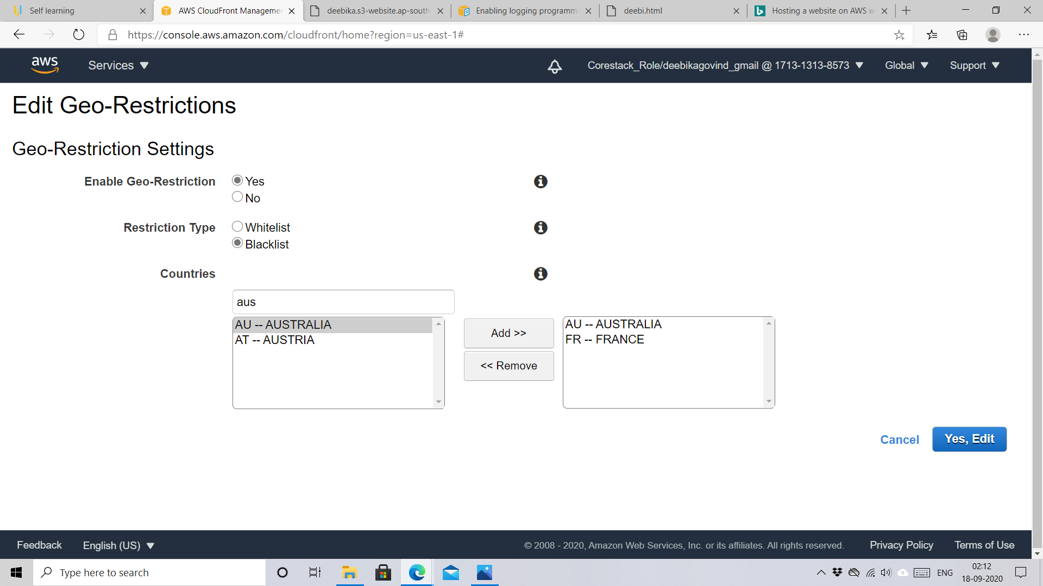

STEP 5:

Verification of Logging.

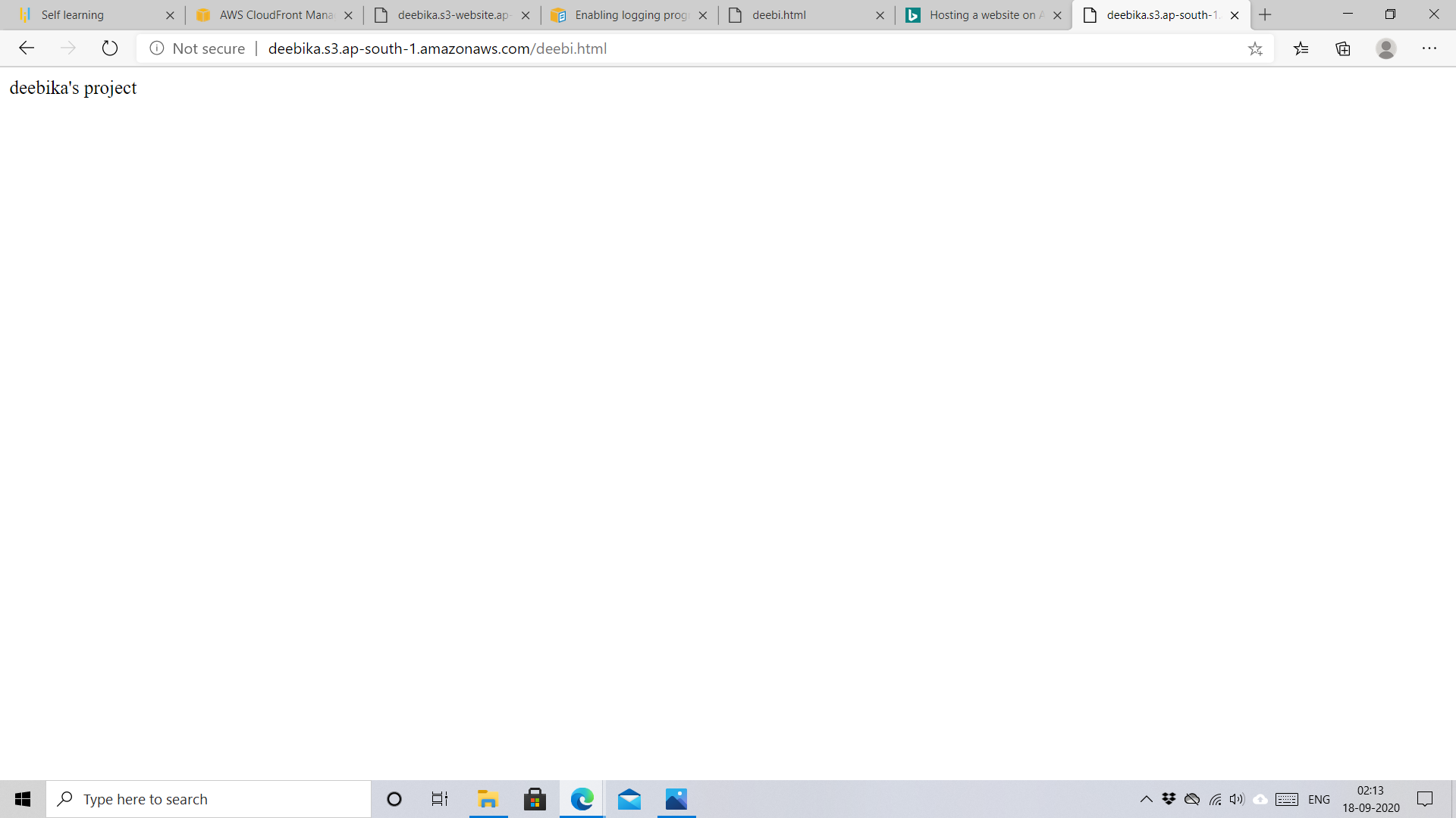

******************************END OF PROJECT ***************************************